 Westmorland General Hospital Accessibility Plan 2017
Location | Car Park | Wheelchair Access | Lift | Fixed or Portable hearing loop system. | Disabled Toilet | Changing Place Toilet | Information & guidance  Please contact
 | 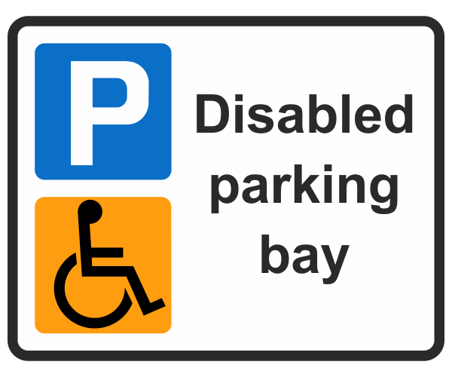 |  | 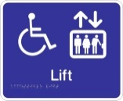 |  | 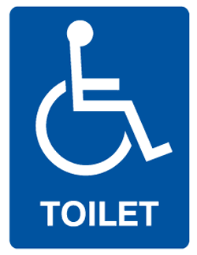 | 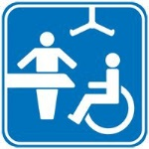 | 
Main Entrance |  |  |  |   Fixed |  |  | Patient Advice and Liaison Service (PALS).  01539 795497  pals@mbht.nhs.uk
Primary Care  Assessment Unit |  |  | Not required | Fixed
Dunmail Day Unit |  |  | Not required | Available from  (PALS).  01539 795497  pals@mbht.nhs.uk
Main Outpatients |  |  | Not required | Available from  (PALS).  01539 795497  pals@mbht.nhs.uk

